2.0 INTRODUCTION

The formatting feature in Word sets each document apart from others. A well-designed document uses formatting to
provide visual cues about its structure. For example: you can work through a document applying formats to headings
and summary paragraphs one by one but Word provides an easier way to store custom combinations of formatting by
defining the combination as a style. You can then apply that combination to a paragraph simply by selecting the style
from the style list.
In this unit, we explore a few more formatting techniques and then show you how to turn combinations of formats into
styles that you can apply with a couple of clicks of the mouse button.
In this unit, you'll learn how to produce attractive documents even when you're in a hurry using the AutoFormat
command on the format menu. This unit introduces you to Templates and Wizards, which serve as models for new
documents.

2.1 OBJECTIVES

After going through this unit, you will be able to
format paragraphs, boarders and shading
align paragraphs in a document
use templates
create document using the existing templates

2.2 FORMATTING TEXT CHARACTERS

Characters include letters, numerals, symbols (such as @, *, and &), punctuation marks, and spaces.
This section provides general information about character formatting. To change the appearance of text, select the text
and then apply the formats you want. If you choose a command without first selecting text, Word applies the formats at the insertion point. Text that you type from that point forward has the new formatting until you change the format
again. Text that you type takes on the formatting of the immediately preceding text.

You can also see which formats are applied to text by selecting the text and looking at the settings on the formatting
toolbar or in the Font dialog box.
Characters formatting tools include:
Pick fonts
Pick fonts sizes
Pick underline styles
Add effects like superscript, subscript etc.
Change default characters
Change characters spacing
Insert special characters and symbols
Change case

Characters Formatting with Formatting Toolbar.

This is used for modifying character appearances.
Example:

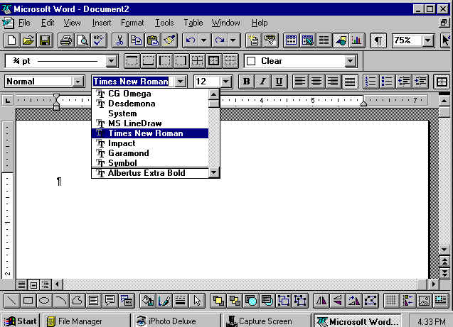

Pick a Font from the formatting toolbar and set point size or toggle between bold, italic, underline as required.

Character Formatting Using Font Dalog Box
Choose Format font command.
Choose Font, the style and size, underline and color settings. A sample is displayed at the bottom with the chosen settings applied.
Effects boxes allow to specify Strike Through, Superscript, Hidden, All Caps etc.

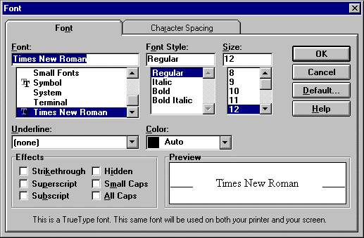
The default button in the Font tab of the dialog box can be used to make the default settings.

Character Spacing
Spacing allows overriding the standard spacing between characters in terms of 1 point.
Choose the text of interest.
Select the character Spacing tab in the Font dialog box. Select Expanded/ Condensed from the Spacing list.
Choose a new setting by typing in the By option box or clicking on the triangles and watch the preview change.
Click OK to save changes.

Color Choice
Choose text of interest
Choose desired color from Color option box in the Font tab of the Font dialog box and click OK.
While printing the document on the printer, enable color setting of the printer.

Changing Case
Select text and choose Format-> Change Case.
Point to the desired option and click OK.
2.3 Formatting Paragraph

In Word, a paragraph is any amount of text, graphics, object or other items that are followed by a paragraph mark. A
paragraph mark is inserted each time while pressing the ENTER key. In order to change the formatting of a paragraph,
select the paragraph and then apply the formats you apply. Paragraph formats affect the entire paragraph and new
paragraphs keep the formatting of the preceding paragraph. Paragraph marks store the format of each paragraph. if the
paragraph mark is deleted, the text in that paragraph becomes part of the next paragraph. The various ways in which the Paragraph formatting can be done is described in the following subsections:

2.3.1 Centering, Right Alignment and Left Alignment

By default, the text in Word is left aligned. These alignments can be changed as described in the previous unit.

2.3.2 Indenting text

Indenting a paragraph enables it to set off from other text.
To indent paragraphs automatically, drag the top half of the triangular indent marker or the ruler to the right to
the desired position. Alternatively, you can select Format Paragraph and enter a setting in the first line
Indent box in the Paragraph dialog box.
To increase or decrease indents by one Tab stop, use the Increase Indent and Decrease Indent button on the
formatting toolbar.
To create a hanging indent (an indent that sticks out beyond the paragraph), drag the top half of the triangular
indent marker to the left to the desired position. You can also select Format * Paragraph and enter a setting
for the first line indent box in the paragraph dialog box that is farther left than the indent of the paragraph as a
whole.
Notice the different between left and right margin and the paragraph indentations.
The margins establish the overall width of the main text area and the space between the main text area and the edges of the page.

Left and right indents are measured from the left and right margins, respectively. The first line indent is measured
relative to the left indent. The negative left-indent measurement for the text appears when the text runs into the left
margin.

2.3.3 Tab Stops

By default, the Tab Stops are set at 0.5-inch intervals from the left margin. The insertion point can be moved to the next tab stop in the current paragraph by pressing the TAB key.
Use the ruler to set a tab stop at a particular position or to change the way text lines up at a tab stop.

To set tab stops

1. Select the paragraph in which you want to set or change tab stops.
2. To set or change the tab alignment, click the Tab Alignment button at the far left of the horizontal ruler until the tab alignment is the way you want it to be.
- On the ruler, click where you want to set a tab stop.

Also you an set precise measurements for tab stops by using the Tabs command on the format menu.
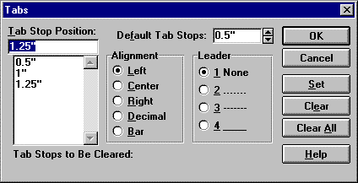

To move a tab stop, point to the tab marker and drag it to a new position. To clear a tab stop, drag the tab marker off the ruler.
The spacing between the default Tab Stops can also be changed but this will affect only the active document.
To do this, type or select the distance you want between the tab stops in the Default Tab Stops box and then click the
OK button.

2.3.4 Line Spacing

Line Spacing determines the height of each line of text in the paragraph. The default (single line spacing) depends on
the size of the font characters. Individual line spacing is easy to change.
The indents and spacing tab of the Paragraph dialog box provides a drop-down for simple but effective control of the
space between lines under most circumstances. The preview area demonstrates the relative effect of single, one-and-a
half and double line spacing. Single spacing causes 12-point line spacing, 1« line spacing is 18 points and double
spaced lines will be 24 points apart.
Choosing the appropriate options from the Line spacing menu in the Paragraph dialog box can make all these line
spacing settings.

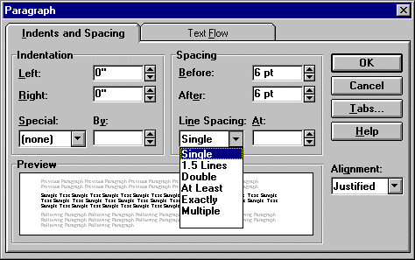

When you use these choices, Word will compensate for graphics, superscript and large or small type sizes.

2.3.5 Paragraph Spacing

Word enables each paragraph to give unique before and after spacing if you wish. The spacing settings can be in
points (pt), inches (in), centimeters (cm) or lines (li).
One advantage to adding space this way is that the spacing before and after paragraphs does not change the point size
of your text. Another advantage is that you can use different spacing combinations for different purposes.
Headings often have different spacing requirements for body text. For instance, you may require different before and
after spacing designs for figures and figure captions as well. Also you can have unique spacing specifications as part
of a style, making it easy to keep the look of your documents consistent.
The Paragraph command on the format menu can be used to add space before and/or the paragraph. The other
advantages of using the Paragraph command are:

1. You can make precise adjustments to the spacing between the various text elements. For example, you can use paragraph spacing to clarify the relationship between headings and body text.
2. If the paragraph is moved or deleted, its spacing goes with it. The paragraph doesn't leave behind extra blank lines.
3. If you include spacing in the paragraph styles you use to format text, Word adds the space along with the other
formatting. You need not add blank lines manually.

2.3.6 Borders and Shading

You can add borders, to any side of a paragraph, and you can add background shading. You can also add borders and
shading to ordinary text and to the paragraphs in table cells and frames

2.4 Document Templates

Document Templates serve as a boilerplate for a new document. It is basically a detailed document with preset text and
formatting on which a new document can be based by amending them according to our requirement.

2.4.1 Template Wizards

To avoid the routine repetitive work of creating new documents, it is best to base them on templates designed for the
types of documents you create most often.
A template is a blueprint for the text, graphics, and formatting of a document. A template also stores styles, macros,
AutoText entries, and customized Word commands settings. These items can help you work faster on a particular type
of document.
Word provides templates for common types of documents, such as memos, reports, business letters, fax forms, invoices
etc. You can use any template as it is or tailor it to your specific requirements.

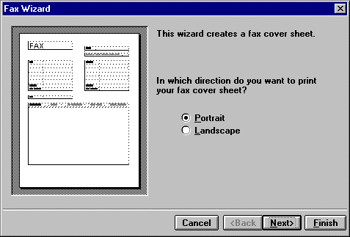

The first time you use the Fax wizard, you required to fill in your personal information and select options for the fax
cover sheet. This information is then automatically placed on the fax cover sheet.
It is only necessary to enter your personal details the first time you use the fax wizard.
An example of how the fax cover sheet will look is displayed. You need to select whether you want it to be printed down the page (Portrait), or across the page (Landscape).
In this example, let us select the "Portrait" setting which is common for fax covers sheets and continue. Click the "Next" button in the dialog box. You can choose that from three styles for the fax cover sheet. The current one is the
"Contemporary" style.

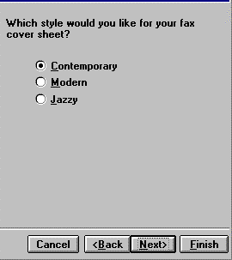

Let's create a fax cover sheet using the "Modern" style. Click the "Modern" style in the dialog box.

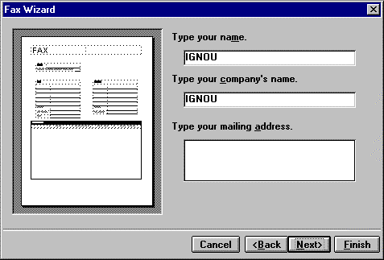

A preview of the "Modern" style fax sheet is displayed. Let's continue by clicking the next button in the dialog box.
The name and company name that was entered during installation is automatically inserted into the "Name" and
"Company Name" boxes. To change it, just enter the names you want in the relevant boxes.
In this example, let's leave this unchanged and enter the mailing address. First, let's click inside the Address box. Let's
enter the mailing address which is (775 Eagle Rd, Lakeside CA 2049) in this example.
Let's go to the next step by clicking the "Next" button in the dialog box.

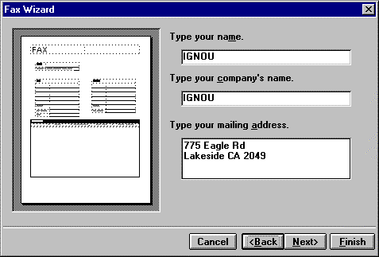

The next step is to enter the fax and telephone number information in the relevant boxes.
In this example, let's assume that our telephone number is (245) 678-6518 and enter it in the "Phone" box and enter the
fax number, which is (245) 678-2171 in the "fax" box.

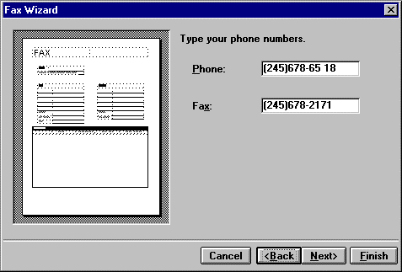

You can go back and change any of the information or selections you made in previous steps via the "Back" button.
The "Finish" button creates the fax sheet with the options and personal information you entered. You typically use this
to create fax cover sheets after the first time, if none of your personal information has changed.
Let's go to the next step by clicking the "Next" button in the dialog box.

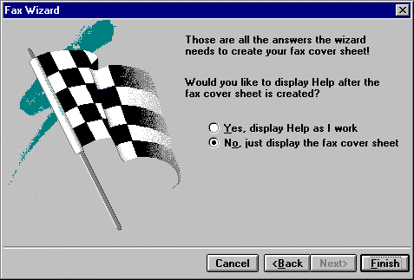

You are given the option of displaying Help after the fax cover sheet is created. Let's accept the default setting which is "No" and create the fax sheet.
A new document for the fax cover sheet has been created.
To display this document at full screen, click the "Full Screen" command in the "View" menu. You now save and name the document as you would any other.
The next time you create a fax sheet with the fax wizard you don't need to enter the sender information unless it has
changed.

2.4.2 Starting a New Document from a Template

You can save time by basing new documents such as memos, letters, and reports on one of the templates that come with Word. From the File menu, choose New, and then select the template you want. The templates you can use are
displayed alphabetically in the "Template" list. "Normal" Template is the default for Word and is the one you use when you click the "New Document" button.
A short description of the current template is displayed in the "Description" box. You select the template that matches
the type of document you want to create. For example, if you want to create invoices you would use the "Invoice"
template.
When you select a template, Word opens a copy of the template as a new document. All of the information in the
template is copied into the new document.

Check Your Progress

1. To copy character formatting from place to place in a document, choose the
a) AutoFormat button
b) Format Painter button
c) Style command in Format menu
d) Style Gallery command in Format menu

2. You can use styles to:
a) format your documents
b) Save changes to documents
c) Delete text in documents
d) Make copies of documents

3. To remove a tab from the ruler
a) Double-click the tab on the Ruler
b) Select the tab and press the Delete key
c) Select the tab and press the backspace key
d) Drag the tab from the ruler

4. The default line spacing for text is
1) 0.5
2) 1.0
3) 1.5
4) 2.0

5. Document templates allow you to
1) Use pre-designed documents for specific purposes
2) Create documents step by step after asking the questions
3) Create and save the document automatically
4) Save the changes to the document

2.5 Summary

In this unit, we have focused our main attention to formatting text, which includes the two kinds of styles:
1. The Paragraph Style
2. The Character Style
By using styles to format text, you can quickly produce professional looking documents and maintain consistent
formatting. Various formatting techniques including embellishing individual characters, changing the indentation of
paragraphs, adjusting the white space between lines and paragraphs etc. have been explained in this unit. The concept
of templates has also been explained.

2.6 MODEL ANSWERS

The questions given in the `Check Your Progress' have been designed only at the conceptual level and the answers to
these questions are directly available in the unit. Therefore, Model Answers have not been provided. However, as this
block is more practical oriented, therefore, students are advised to try the commands given, on their terminals.

Formatting Text

20

16

